Transracial Parenting Networking Group
London Satellite Site

Presents

What does(n’t) it mean to be adopted?

Dr. Robert Ballard, Assistant Professor, Communication, Leadership and Social Innovation, University of Waterloo
&
Ms. Sarah Ballard, M.A., Colorado Licensed Professional Counselor

Grounded in the Ballards’ personal narratives, this presentation explores some of the misunderstandings and challenges faced by adoptees and their families. The Ballards offer practical experience, scholarly research, and concrete advice for adoptive families and adoption policy. There will be a Q & A session following their presentation.

This event is free and open to the public!

Friday, April 9th, 2010
TIME: 6:30pm – 8:30pm
LOCATION: Childreach; 265 Maitland St; London, 2nd Floor Classroom

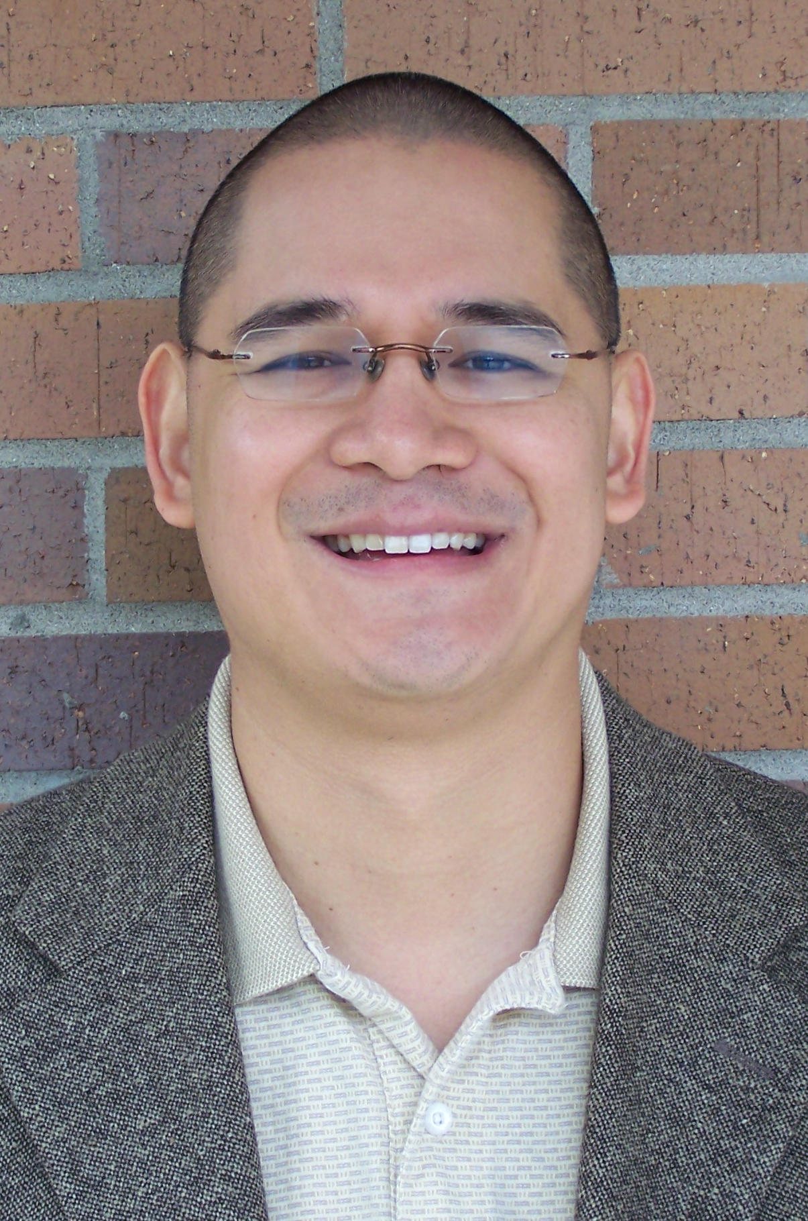
In addition to serving as an assistant professor, Dr. Ballard is a Vietnamese adoptee. He is also an adoption writer, researcher (specializing in adoptee identity and adoptive family communication). He is the editor of Pieces of Me: Who do I Want to Be? for adopted teens as well as an international speaker and workshop presenter, and consultant. He has co-founded two adoptee-led organizations, is the advisor of a forthcoming documentary film on Operation Babylift, and a prospective adoptive parent to a son from Vietnam. He and his wife, Sarah, have two biological children, both girls ages 7 and 6.

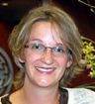
Prior to re-locating to Waterloo, Ms. Ballard had a successful counseling practice specializing in international and transracial adoption. She is the author of Xpress Yourself!, a play therapy based curriculum for international and transracial adoptee groups. She has led a variety of adoption workshops and is a sought after adoption speaker and trainer. She has four adopted siblings from Korea and is a prospective adoptive parent to a son from Vietnam. She currently teaches for the University of Waterloo in Communication, Leadership and Social Innovation. She and her husband, Bert, have have two biological children, both girls ages 7 and 6.



